Some of the LNF expectations for your child include:
Using Number Skills
- Count sets of objects by grouping in 2s, 5s or 10s.
- Read and write numbers to 100.
- Compare and order 2-digit numbers.
- Use mental recall of number facts to 10 to derive other facts, i.e.
  - doubling and halving, e.g. derive 40 + 40 from knowing 4 + 4
  - bonds of 10, e.g. derive 60 + 40 from knowing 6 + 4
- Recall and use 2, 5 and 10 multiplication tables.
- Find halves and quarters in practical situations.
- Use mental recall of number facts to 10 and place value to add or subtract larger numbers, e.g. 24 + 4, 30 + 5, 34 +10
- Find small differences within 20 by using counting-on strategies.
- Use checking strategies, e.g. repeat addition in a different order/use halving and doubling within 20.
- Use different combinations of money to pay for items up to £1.
Using Measuring Skills
- Use standard units to measure length, height and distance (metres, half metres or centimetres), weight/mass (kilograms or 10 gram weights) and capacity (litres).
- Read half-past, quarter-past and quarter-to on an analogue clock.
- Read hours and minutes on a 12-hour digital clock.
Using Data Skills
- Gather and record data from lists and tables, diagrams, block graphs and pictograms.
- Extract and interpret information from lists, tables, diagrams and graphs.
Developing Numerical Reasoning
- Identify steps to complete the task or reach a solution.
- Select appropriate mathematics and techniques to use.
- Select and use relevant number facts and mental strategies.
Supporting children in Numeracy

A leaflet for parents
Help your child with numeracy

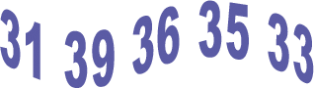

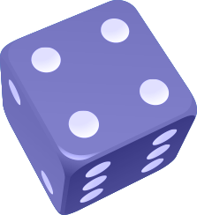
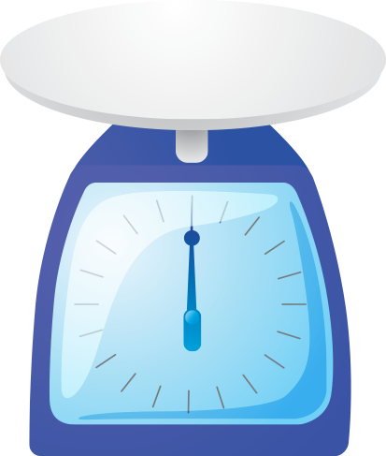
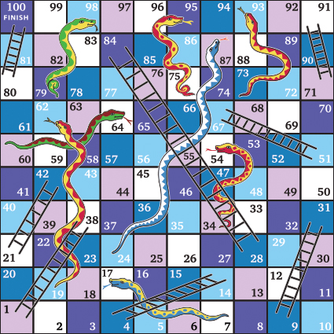
Number facts
You need a 1–6 dice.
Take turns. Roll the dice. See how quickly you can say the number to add to the number on the dice to make 10, e.g.

and 6

If you are right, you score a point.
The first to get 10 points wins.
You can extend this activity by making the two numbers add up to 20, or 50.
Out and about
During a week, look outside for ‘thirties’ numbers, such as 34 or 38, on house doors, number plates, bus stops, etc. How many can you spot? What is the biggest one you can find?

Next week, look for ‘fifties’ numbers, or ‘sixties’.
Shopping maths
After you have been shopping, choose six different items each costing less than £1. Make a price label for each one, e.g. 39p, 78p. Shuffle the labels. Then ask your child to do one or more of the following.
- Place the labels in order, starting with the lowest.
- Say which price is an odd number and which is an even number.
- Add 9p to each price in their head.
- Take 20p from each price in their head.
- Say which coins to use to pay exactly for each item.
- Choose any two of the items, and find their total cost.
- Work out the change from £1 for each item.
How heavy?
You will need some kitchen scales that can weigh things in kilograms.
Ask your child to find something that weighs close to 1 kilogram.
Can he/she find something that weighs exactly 1 kilogram?
Find some things that weigh about half a kilogram.
Board games
Make a board like this. The numbers are arranged differently from usual, but the games will still work if you use a normal snakes and ladders board.
Roll a dice twice. Add the two numbers.
Move along that number of spaces. Before you move, you must work out what number you will land on.
If you are wrong, you don’t move!
The first to the end of the board wins.
For a change, you could roll the dice and move backwards. Or you could roll the dice once, then move the number that goes with your dice number to make 10,
e.g. throw a 3, move 7.

Straight lines
Choose four different lengths between 5 and 20 centimetres. Use a ruler marked in centimetres. Draw lines of each length.

How much?
Once a week, tip out the small change from a purse. Count it up with your child.

