Some of the LNF expectations for your child include:
Using Number Skills
- Read and write numbers to 1000.
- Compare and estimate with numbers up to 100.
- Use mental strategies to recall number facts within 20.
- Recall 2, 3, 4, 5 and 10 multiplication tables and use to solve multiplication and division problems.
- Multiply numbers by 10.
- Find differences within 100.
- Use mental strategies to add and subtract 2-digit numbers.
- Use partitioning to double and halve 2-digit numbers.
- Check subtraction using addition, check halving using doubling and check multiplication using repeated addition.
- Use different combinations of money to pay for items up to £2 and calculate the change.
- Order and compare items up to £10.
Using Measuring Skills
- Use standard units of measure: length (measure on a ruler to the nearest ½ cm), weight/mass (use 5g, 10g and 100g weights) and capacity (use litres and half litres; measure to the nearest 100ml).
- Tell the time to the nearest 5 minutes on an analogue clock and calculate how long it is to the next hour.
Using Data Skills
- Represent data using lists, tally charts, tables, diagrams, bar charts, pictograms and Venn and Carroll diagrams.
- Extract and interpret information from charts, timetables, diagrams and graphs.
Developing Numerical Reasoning
- Transfer mathematical skills to a variety of contexts and everyday situations.
- Select appropriate mathematics and techniques to use.
- Select and use suitable instruments and units of measurement.
- Explain results and procedures clearly using mathematical language.
Supporting children in Numeracy

A leaflet for parents
Help your child with numeracy



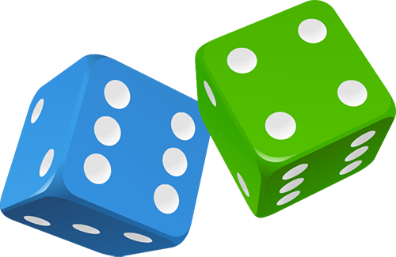
Can you tell the time?
Whenever possible, ask your child to tell you the
time to the nearest five minutes. Use a clock with
hands as well as a digital watch or clock.
Also ask:
- What time will it be one hour from now?
- What time was it one hour ago?
Time your child doing various tasks, e.g.
- getting ready for school
- tidying a bedroom
- saying the 5 times, 10 times or 2 times table…
Ask your child to guess in advance how long they think an activity will take. Can they beat their time when they repeat it?
Make 20
For this game you need to write out numbers 0 to 20 on a piece of paper. Make them big enough to put counters or coins on.
Take turns. Roll a dice. Put a coin on the number that goes with the dice number to make 20, e.g. throw a ‘4’ and put a coin on 16.
If someone else’s counter is there already, replace it with yours!
The first person to have counters on six different numbers wins.
Now roll two dice, add the numbers together and look for a number to make 20. The first with coins on 10 different numbers wins.
Secret sums
Ask your child to say a number, e.g. 43.
Secretly do something to it (e.g. add 30).
Say the answer, e.g. 73.
The child then says another number to you, e.g. 61.
Do the same to that number and say the answer.
The child has to guess what you are doing to the number each time!
Then they can have a turn at secretly adding or subtracting something to each number that you say to them.
Bean race
You need two dice and a pile of dried beans.
Take turns to roll the two dice.
Multiply the two numbers and call out the answer.
If you are right, you win a bean.
The first to get 10 beans wins.
Number games
Roll two dice. Make two-digit numbers, e.g. if you roll a 6 and 4, this could be 64 or 46. If you haven’t got two dice, roll one dice twice. Ask your child to do one or more of the activities below.
- Count on or back from each number in tens.
- Add 19 to each number in their head.
(A quick way is to add 20 then take away 1.)
- Subtract 9 from each number.
(A quick way is to take away 10 then add back one.)
- Double each number.
Cupboard maths
Ask your child to look at the weights printed on jars, tins and packets in the food cupboard, e.g.
tinned tuna 185g
tinned tomatoes 400g
jam 454g
Choose six items. Ask your child to put them in order. Is the largest item the heaviest?
Fractions
Use 12 buttons, or paper clips or dried beans etc.
Ask your child to find half of the 12 things.
Now find one quarter of the same group.
Find one third of the whole group.
Repeat with other numbers.
Bingo!
One person has the 2x table and the other has the 5x table. Write six numbers in that table on your piece of paper, e.g.
4 8 10 16 18 20
Roll one or two dice. If you choose to roll two dice, add the numbers, e.g. roll two dice, get 3 and 4, add these to make 7.
Multiply that number by 2 or by 5 (that is, by your table number, e.g. 7 x 2 or 7 x 5).
If the answer is on your paper, cross it out.
The first to cross out all six of their numbers wins.

