Some of the LNF expectations for your child include:
Using Number Skills
- Read and write numbers to 10 000.
- Compare and estimate with numbers up to 1 000
- Use mental strategies to recall multiplication tables for 2, 3, 4, 5, 6 and 10 and use to solve division problems.
- Multiply and divide numbers by 10 and 100.
- Find differences within 1 000.
- Add a 2-digit number to, and subtract a 2-digit number from, a 3-digit number using an appropriate mental or written method.
- Use mental strategies to multiply and divide 2-digit numbers by a single-digit number.
- Estimate by rounding to the nearest 10 or 100.
- Use money to pay for items up to £10 and calculate the change.
- Order and compare items up to £100.
Using Measuring Skills
- Measure on a ruler to the nearest mm and record using a mix of units,
e.g. 1cm 3mm.
- Use weighing scales with divisions to weigh objects to the nearest 5g, 10g,
25g or 100g.
- Measure capacities to the nearest 50ml or 100ml.
Using Data Skills
- Represent data using lists, tally charts, tables, diagrams, bar charts, pictograms and Venn and Carroll diagrams.
- Extract and interpret information from charts, timetables, diagrams and graphs.
Developing Numerical Reasoning
- Transfer mathematical skills to a variety of contexts and everyday situations.
- Select appropriate mathematics and techniques to use.
- Select and use suitable instruments and units of measurement.
- Explain results and procedures clearly using mathematical language.
Supporting children in Numeracy

A leaflet for parents
Help your child with numeracy

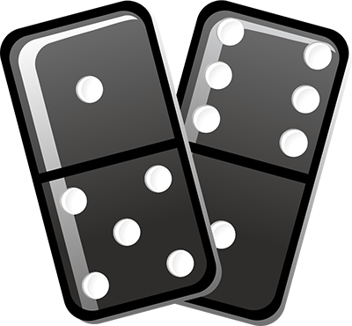
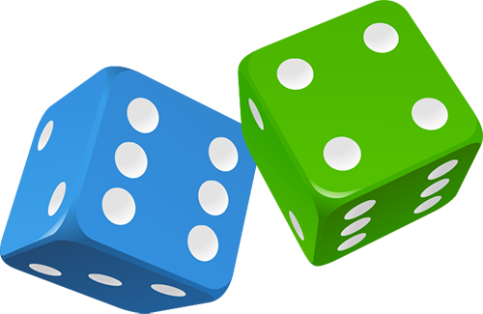
Measuring
Use a tape measure that shows centimetres.
Take turns measuring lengths of different objects, e.g. the length of a sofa, the width of a table, the length of the bath, the height of a door.
Record the measurement in centimetres, or metres and centimetres if it is more than a metre, e.g. if the bath is 165 cm long, you could say it is 1m 65cm (or 1.65m).
Write all the measurements in order.
Looking around
Choose a room at home.
Challenge your child to spot 20 right angles in it.
Pairs to 100
This is a game for two players.
Each draw 10 circles. Write a different two-digit number in each circle – but not a ‘tens’ number (10, 20, 30, 40…). In turn, choose one of the other player’s numbers.
The other player must then say what to add to that number to make 100, e.g. choose 64, add 36.
If the other player is right, she crosses out the chosen number.
The first to cross out six numbers wins.
Number game 1
You need about 20 counters or coins.
Take turns. Roll two dice to make a two-digit number, e.g. if you roll a 4 and 1, this could be 41 or 14. Add these two numbers in your head. If you are right, you win a counter. Tell your partner how you worked out the sum.
The first to get 10 counters wins.
Now try subtracting the smaller number from the larger one.
Number game 2
Put some dominoes face down.
Shuffle them.
Each choose a domino.
Multiply the two numbers on your domino.
Whoever has the biggest answer keeps the two dominoes.
The winner is the person with the most dominoes when they have all been used.

Number game 3
Use three dice. If you have only one dice, roll it three times.
Make three-digit numbers, e.g. if you roll 2, 4 and 6,
you could make 246, 264, 426, 462, 624 and 642.
Ask your child to round the three-digit number to the
nearest multiple of 10. Check whether it is correct, e.g.
76 to the nearest multiple of 10 is 80.
134 to the nearest multiple of 10 is 130.
(A number ending in a 5 always rounds up.)
Roll again. This time round three-digit numbers to the nearest 100.
Mugs
You need a 1 litre measuring jug and a selection of different mugs, cups or beakers.
Ask your child to fill a mug with water.
Pour the water carefully into the jug.
Read the measurement to the nearest 10 millilitres.
Write the measurement on a piece of paper.
Do this for each mug or cup.
Now ask your child to write all the measurements in order.
Sum it up
Each player needs a dice.
Say: Go! Then each rolls a dice at the same time.
Add up all the numbers showing on your own dice, at the sides as well as at the top.
Whoever has the highest total scores 1 point.
The first to get 10 points wins.

