Some of the LNF expectations for your child include:
Using Number Skills
- Read and write numbers to 100 000.
- Compare numbers with one and two decimal places.
- Use mental strategies to recall multiplication tables for 2, 3, 4, 5, 6, 8 and 10 and use to solve division problems.
- Use doubling and halving strategies.
- Use understanding of simple fraction and decimal equivalences when measuring and calculating.
- Find differences between numbers with one decimal place.
- Add and subtract 3-digit numbers using an appropriate mental or written method.
- Multiply and divide 3-digit numbers by a single-digit number.
- Estimate by rounding to the nearest 10, 100 or 1 000.
- Order and compare the cost of items up to £1 000.
- Add and subtract totals less than £100 using correct notation,
e.g. £28.18 + £33.45.
Using Measuring Skills
- Read and use analogue and digital clocks.
- Time events in minutes and seconds, and order the results.
- Carry out practical activities involving timed events and explain which unit of time is the most appropriate.
Using Data Skills
- Extract and interpret information from diagrams, timetables and charts.
- Represent data using lists, tally charts, diagrams, bar charts, line graphs etc.
Developing Numerical Reasoning
- Transfer mathematical skills to a variety of contexts and everyday situations.
- Select appropriate mathematics and techniques to use.
- Select and use suitable instruments and units of measurement.
- Explain results and procedures clearly using mathematical language.
Supporting children in Numeracy

A leaflet for parents
Help your child with numeracy

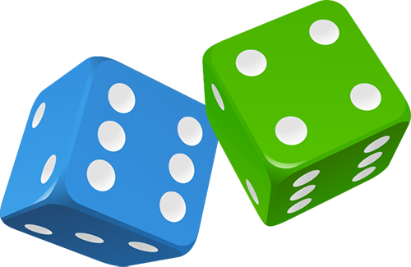


Telephone challenges
Challenge your child to find numbers in the telephone directory where the digits
add up to 42.
Find as many as possible in 10 minutes.
On another day, see if they can beat their previous total.
Line it up
You need a ruler marked in centimetres and millimetres.
Use the ruler to draw 10 different straight lines on a piece of paper.
Ask your child to estimate the length of each line and write the estimate on the
line.
Now give them the ruler and ask them to measure each line to the nearest millimetre.
Ask them to write the measurement next to the estimate, and work out the difference.
A difference of 5 millimetres or less scores 10 points. A difference of 1 centimetre or less scores 5 points.
How close to 100 points can he/she get?

Dicey subtractions
Take turns to roll a dice twice.
Fill in the missing boxes.
400☐ – 399☐
e.g. 4002 – 3994

Count on from the smaller to the larger number,
e.g. 3995, 3996, 3997, 3998, 3999, 4000, 4001, 4002.
You counted on eight, so you score eight points.
Keep a running total of your score. The first to get 50 or more points wins.
Guess my number
Choose a number between 0 and 1 with one decimal place, e.g. 0.6.
Challenge your child to ask you questions to guess your number. You may only answer ‘Yes’ or ‘No’. For example, he/she could ask questions like ‘Is it less than
a half?’
See if he/she can guess your number in fewer than five questions.
Now let your child choose a mystery number for you to guess.
Extend the game by choosing a number with one decimal place between 1 and 10, e.g. 3.6. You may need more questions!
How much?
While shopping, point out an item costing less than £1.
Ask your child to work out in their head the cost of three items.
Ask them to guess first.
See how close they come.
If you see any items labelled, for example, ‘2 for £3.50’, ask
them to work out the cost of one item for you, and to explain how
they got the answer.
Dicey division
For this game you need a 1–100 board (a snakes and ladders board will do), a dice and 20 coins or counters.
Take turns.
Choose a two-digit number. Roll a dice. If you roll 1, roll again.
If your two-digit number divides exactly by the dice number, put a coin on your chosen two-digit number. Otherwise, miss that turn.
The first to get 10 counters on the board wins.
Times tables
Say together the 6 times table forwards, then backwards. Ask your child questions, such as:
Nine sixes? How many sixes in 42?
Six times four? Forty-eight divided by six?
Three multiplied by six? Six times what equals sixty?
Repeat with the 8 and 10 times tables.

