Some of the LNF expectations for your child include:
Using Number Skills
- Read and write numbers to 1 million and numbers to three decimal places.
- Use mental strategies to recall multiplication tables up to 10 x 10 and use to solve division problems.
- Use understanding of simple fraction, decimal and percentage equivalences.
- Calculate percentage quantities based on 10%.
- Add and subtract numbers using whole numbers and decimals.
- Multiply 2- and 3-digit numbers by a 2-digit number.
- Divide 3-digit numbers by a 2-digit number.
- Estimate by rounding to the nearest 10, 100, 1 000 or whole number.
- Make comparisons between prices and understand which is best value for money.
Using Measuring Skills
- Read and interpret scales or divisions on a range of measuring instruments.
- Time events in minutes and seconds to the nearest tenth of a second.
- Use and interpret timetables and schedules.
- Estimate how long a journey takes.
- Measure and record temperatures including positive and negative readings and calculate temperature differences.
Using Data Skills
- Extract and interpret information from diagrams, timetables and charts.
- Represent data using lists, tally charts, diagrams, bar charts, line graphs etc.
Developing Numerical Reasoning
- Transfer mathematical skills to a variety of contexts and everyday situations.
- Select appropriate mathematics and techniques to use.
- Select and use suitable instruments and units of measurement.
- Explain results and procedures clearly using mathematical language.
Supporting children in Numeracy

A leaflet for parents
Help your child with numeracy

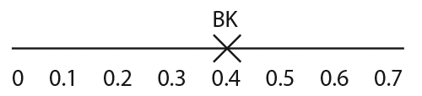
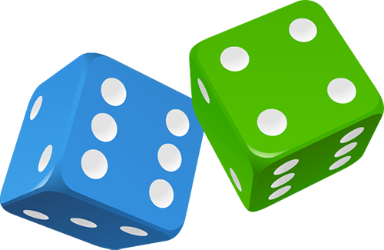
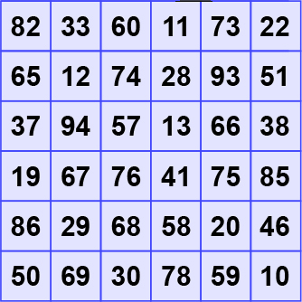
Remainders
Draw a 6 x 6 grid like this.

Choose the 7, 8 or 9 times table.
Take turns.
Roll a dice.
Choose a number on the board, e.g. 59. Divide it
by the tables number, e.g. 7. If the remainder for
59 ÷ 7 is the same as the dice number, you
can cover the board number with a counter or coin.
The first to get four of their counters in a straight line wins!
Doubles and trebles
Roll two dice.
Multiply the two numbers to get your score.
Roll one of the dice again. If it is an even number, double
your score. If it is an odd number, treble your score.
Keep a running total of your score.
The first to get over 301 wins.
Favourite food
Ask your child the cost of a favourite item of food.
Ask them to work out what seven of them would cost, or eight, or nine.
How much change would there be from £50?
Repeat with his/her least favourite food.
What is the difference in cost between the two?
Recipes
Find a recipe for four people and rewrite it for eight people, e.g.
Four people: Eight people:
125g flour 250g flour
50g butter 100g butter
75g sugar 150g sugar
30ml treacle 60ml treacle
1 teaspoon ginger 2 teaspoons ginger
Can you rewrite it for three people? Or five people?
Three in a row
For this game you need a calculator.
Draw a line like this:

Take it in turns to choose a fraction, say 2/5.
Use the calculator to convert it to a decimal (i.e. 2 ÷ 5 = 0.4) and mark your initials at this point on the line.
The aim of the game is to get three crosses in a row without any of the other player’s marks in between.
Some fractions are harder to place than others, e.g. ninths.
Fours
Use exactly four 4s each time.
You can add, subtract, multiply or divide them.
Can you make each number from 1 to 100?
Here are some ways of making the first two numbers.
1 = (4 + 4)/(4 + 4)
2 = 4/4 + 4/4
TV addicts
Ask your child to keep a record of how long he/she watches TV each day for a week. Then ask them to do this.
Work out the total watching time for the week.
Work out the average watching time for a day (that is, the total time divided by 7).
Instead of watching TV, you could ask them to keep a record of time spent eating meals, or playing outdoors, or anything else they do each day. Then work out the daily average.
Sale of the century
When you go shopping, or see a shop with a sale on, ask your child to work out what some items would cost with: 50% off, 25% off, 10% off, 5% off.
Ask your child to explain how he/she worked it out.
A million pounds
Assume you have £1 000 000 to spend or give away.
Plan with your child what to do with it, down to the last penny.

